# Load Balance Task

1. Configure Classic Load balancer.

* Go to the aws Dashboard.
* Create 2 ec2 instances. With different regions. (EX.us-east-1a, us-east-1b)
* Then create a Classic load balncer.
* Nd create a target groups.
* **Attach ssl certificate for classic load balnacer**

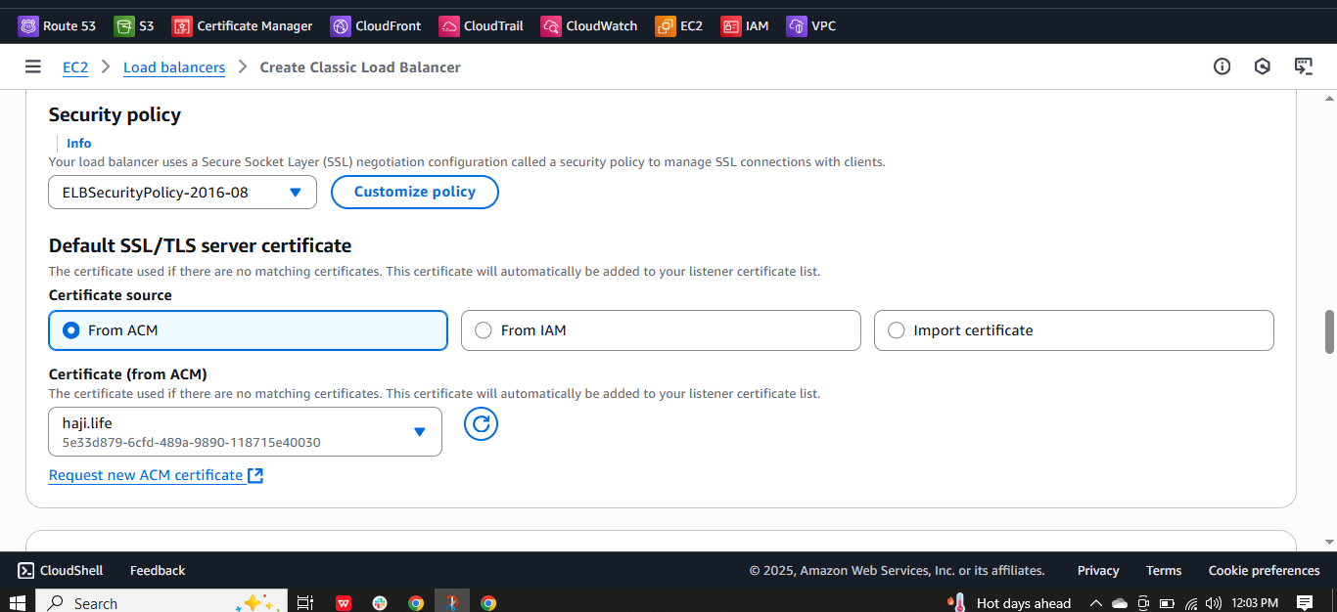

* **Nd pi ng path is index.html**

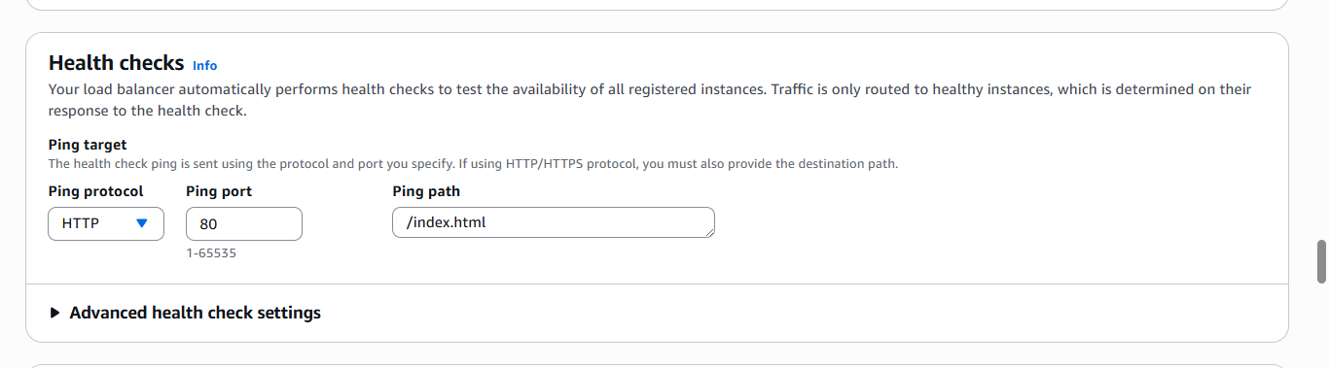

* **Nd here the two instances.**

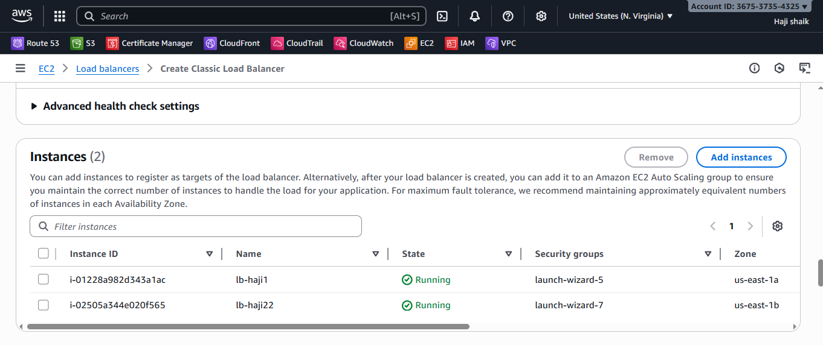

* **Nd here the summary of LB:**

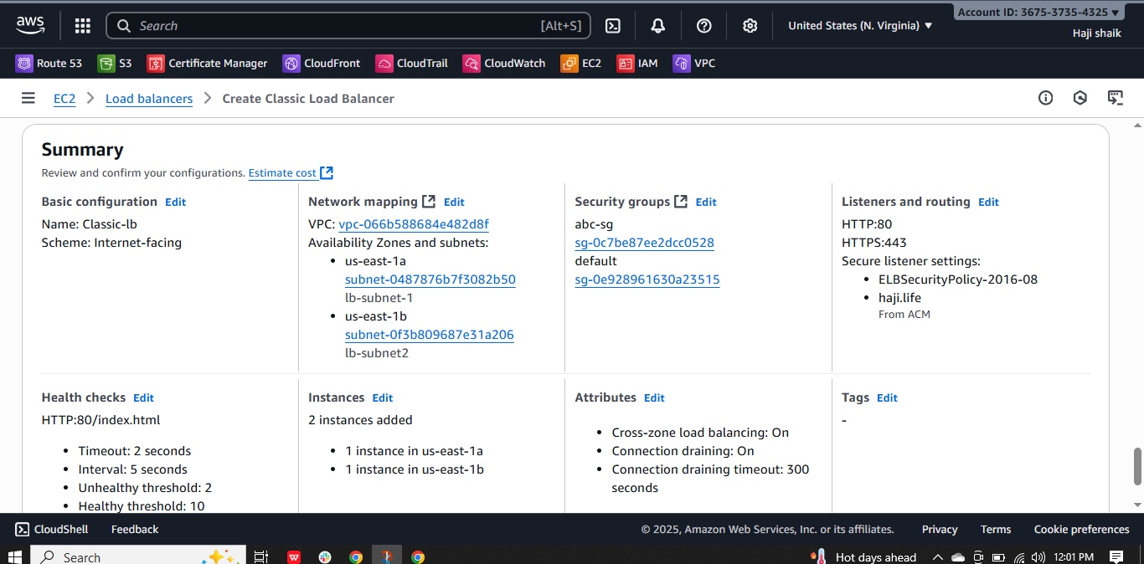

* 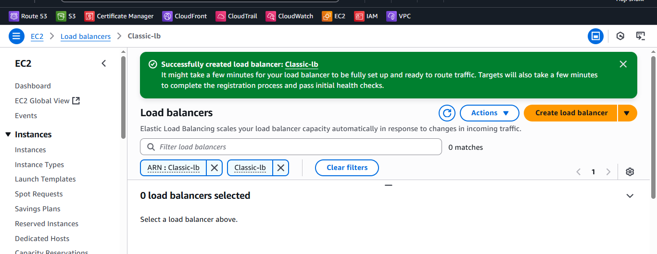
* **Nd here the results of public ip:**

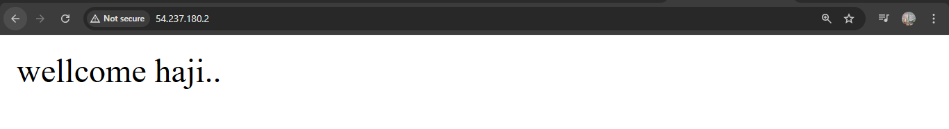

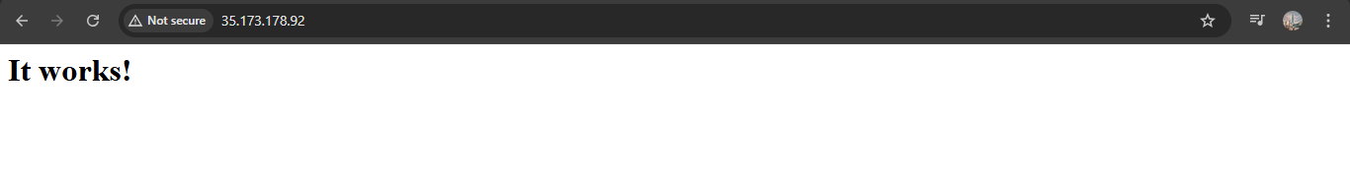

* **Nd then result with DNS copied name:**

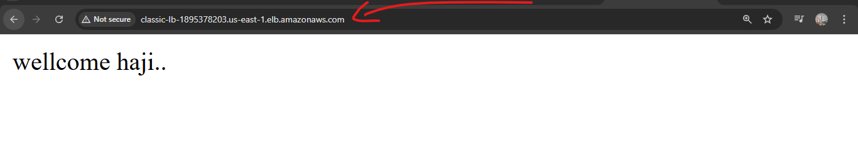

* **Nd then finally with /index.html**

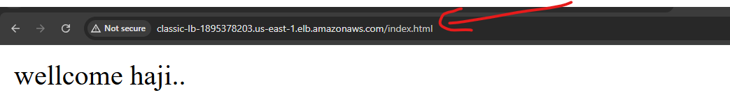

1. Configure Application Load balancer.

* Go to the aws Dashboard.
* Create 2 ec2 instances. With different regions. (EX.us-east-1a, us-east-1b)
* Then create a load balncer.
* Nd create a target groups.

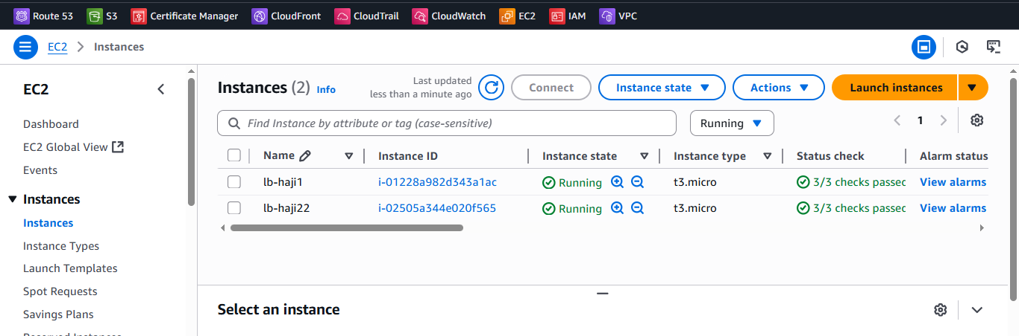

* Nd create a Load balancer.

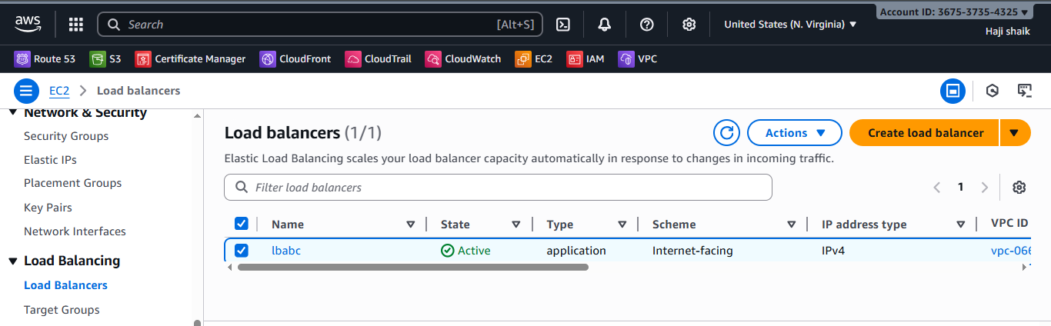

* Nd listner port:90

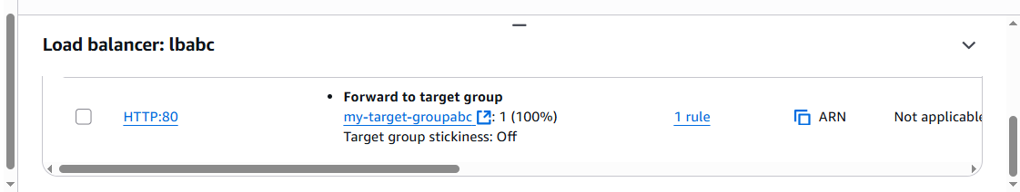

* Nd create a to instances in different 2 Regions.

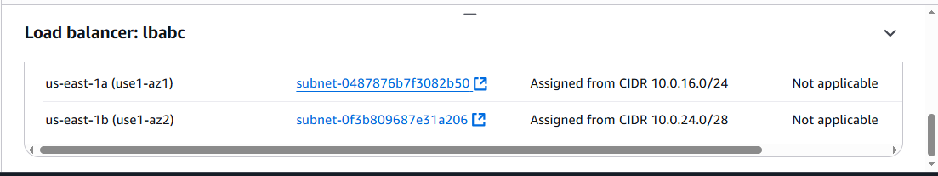

* **2 instances are Healthy:**

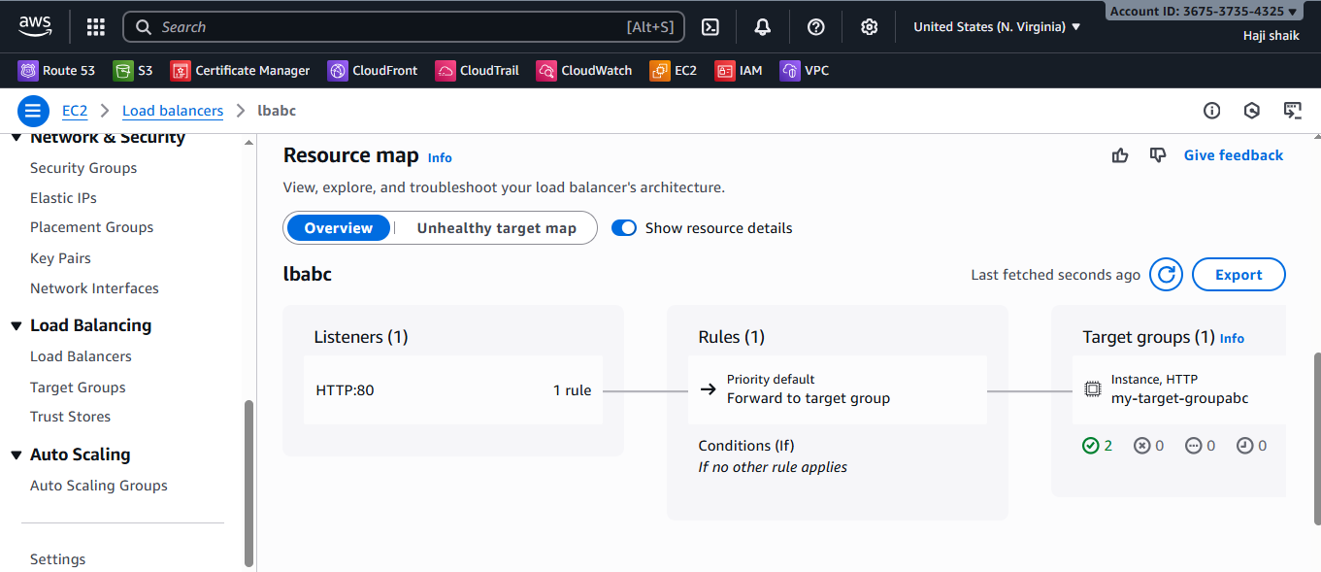

* Nd here the results are 2 different instances.

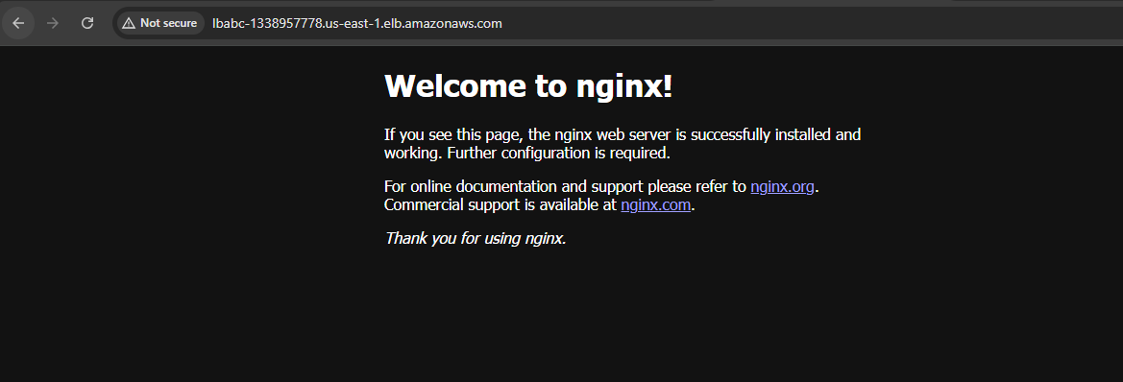

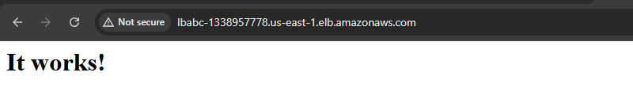

1. Configure Network Load balancer.

* Go to the aws Dashboard.
* Create 2 ec2 instances. With different regions. (EX.us-east-1a, us-east-1b)
* Then create a network load balncer.
* Nd create a target group for for network load balncer.
* **Step-1**.

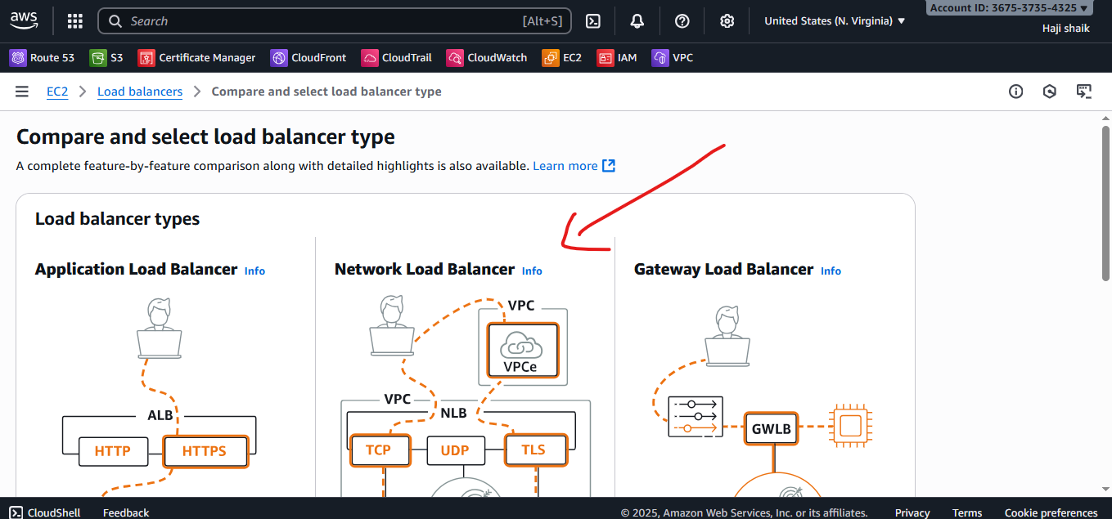

* **Step-2.**

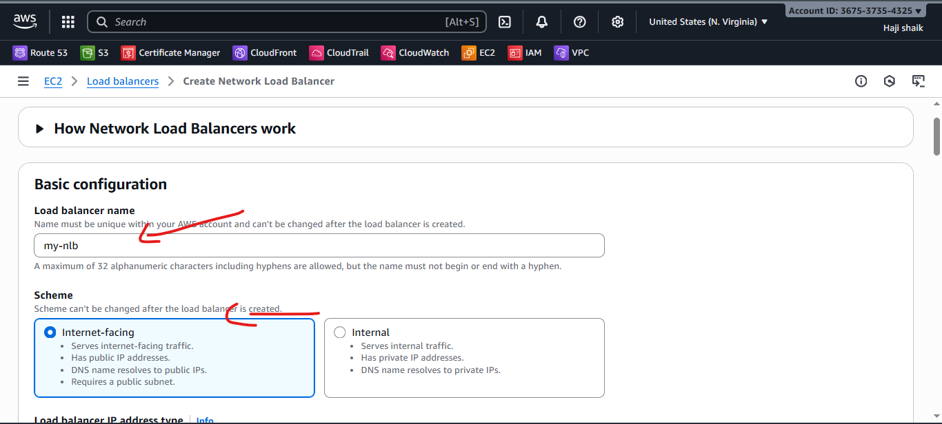

* **Step-3**

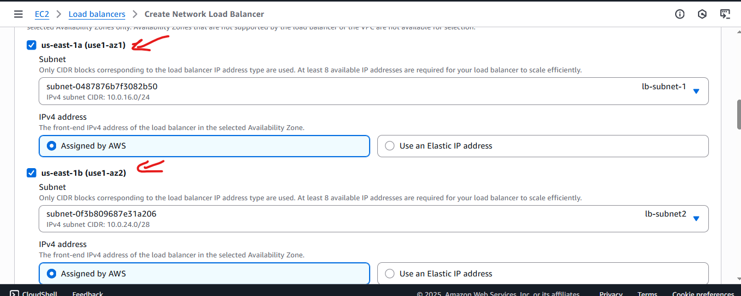

* **Step-4**

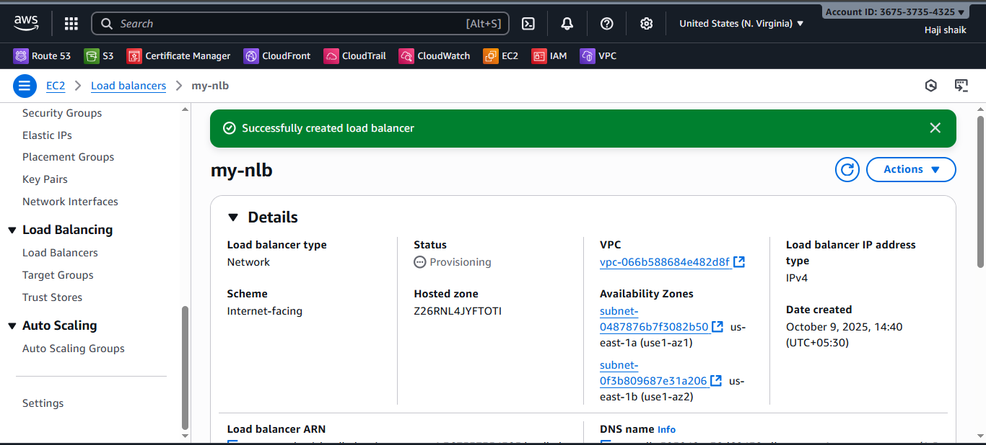

* **Step-1**.

Here the results are:

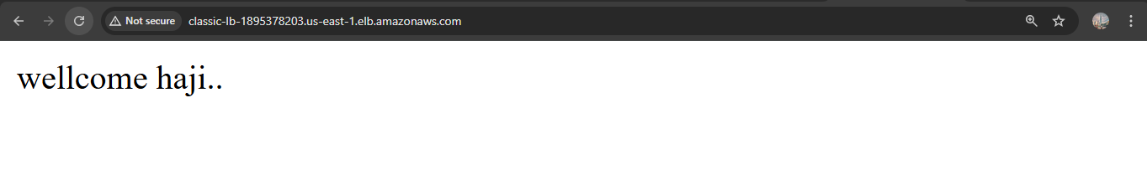

1. Attach SSL for application load balancer.

* Go to the aws console.
* Nd create the load balncer for application.
* We need to attach **SSL certificate for this load balncer.**



1. Map Application load balancer to R53.

* Creating apllication load balncer
* Then go to route 53.
* create hosted name with ur domain.
* Then create a record.
* Nd turn alias.
* Then nd that choose aplication load balncer.
* Then select ur load balncer on it.
* Then wait for its available.
* Then here the results are:
* <http://haji.life>

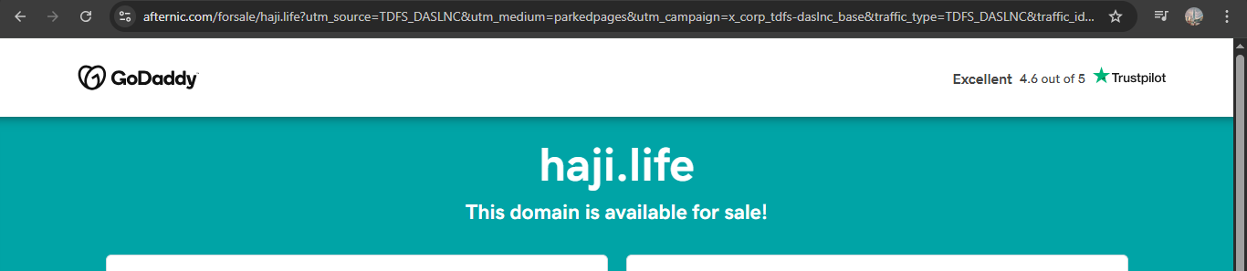

1. Push the application load balancer logs to S3.

* **Go**  to the aws console.
* Then open search bar and go to the s3 bucket.
* Nd create a s3 bucket with a unique name.

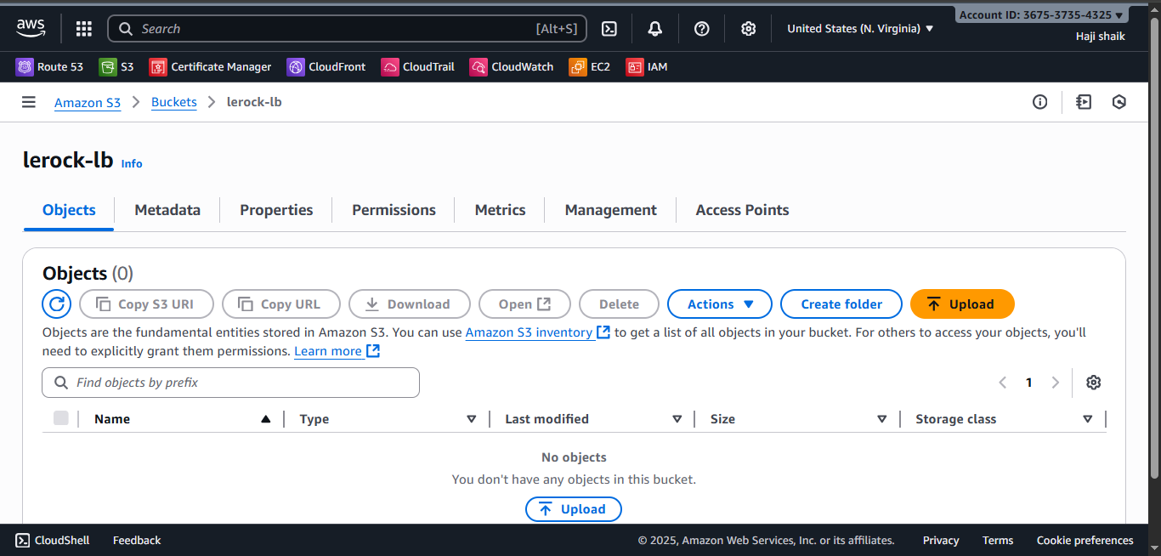

* **Go**  to the permissons in s3 bucket.
* Then edit a policy and use refernce from google.
* Here the script are.
* {  
    "Version": "2012-10-17",  
    "Statement": [  
      {  
        "Sid": "AWSALBLoggingPermissions",  
        "Effect": "Allow",  
        "Principal": {  
          "Service": "[logdelivery.elasticloadbalancing.amazonaws.com](http://logdelivery.elasticloadbalancing.amazonaws.com/" \t "https://app.slack.com/client/T03TRQ064Q0/_blank)"  
        },  
        "Action": "s3:PutObject",  
        "Resource": "arn:aws:s3:::<BUCKET_NAME>/AWSLogs/<ACCOUNT_ID>/*"  
      }  
    ]  
  }

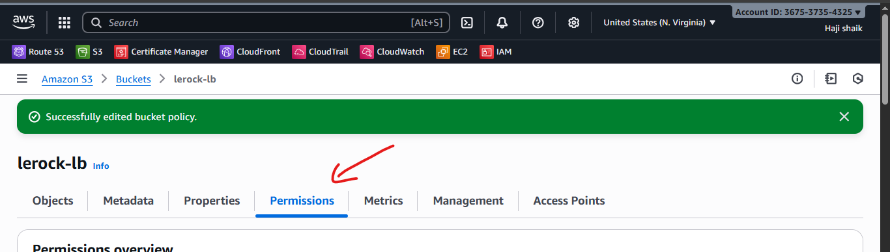

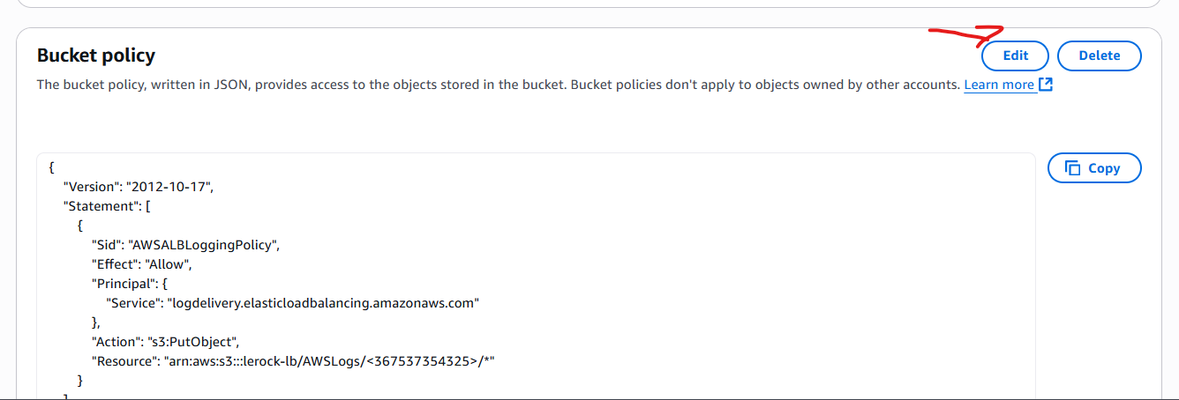

* **Go**  to the load balncer again.
* Go the **Attributes**.
* Then in bottom there is Monitoring Option.
* Enable access log option there choose your **S3 bucket.**

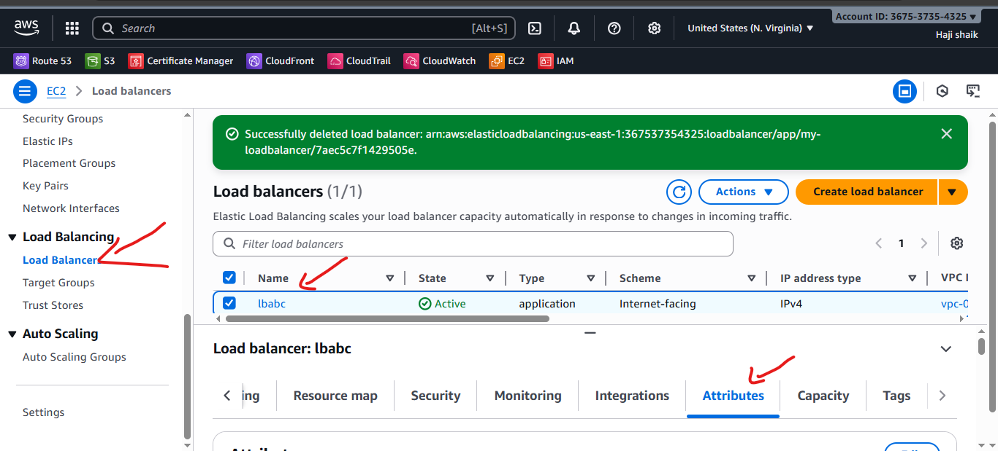

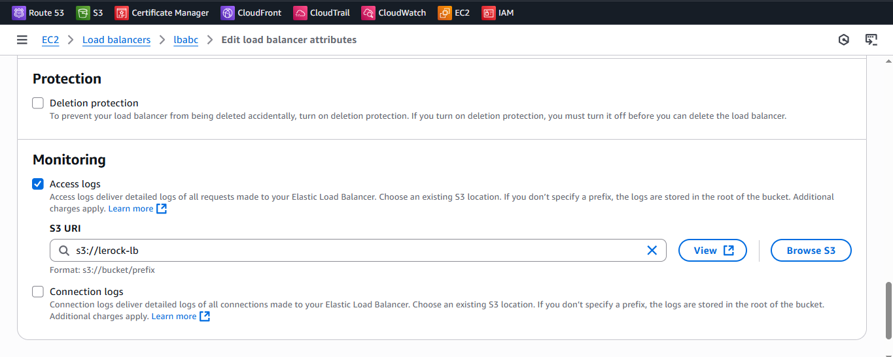

* Then **go back to the S3 bucket refresh the page.**
* **Open a object bar here the results are:**

